Transferring PLC data between an ATA Flash Card and a Fanuc 21i CNC control

- Turn the control OFF
- Insert the ATA Flash card into the card slot on the front of the Fanuc 21i control
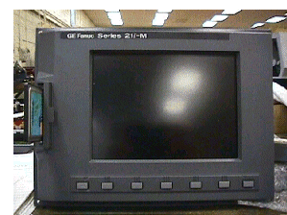
- Press and hold the TWO right hand soft keys below the LCD screen, whilst at the SAME TIME turn the control ON
Hold Down These Keys
- A Boot menu appears.
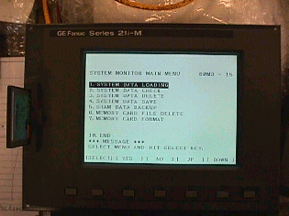
- To transfer a PLC program FROM the ATA Flash card TO the CNC Control:
Press [SELECT]

a) Use the cursor keys to select option ‘ System Data Loading‘
b) Press the [SELECT] soft key
c) A list of available files in the ATA Flash card appears. Use the cursor keys to choose the correct file name then press [SELECT]
d) When asked if you want to load the selected file press [YES]
- 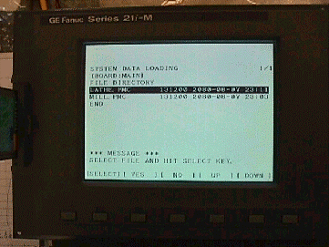Turn the control OFF, then ON to restart the CNC control for normal operation

